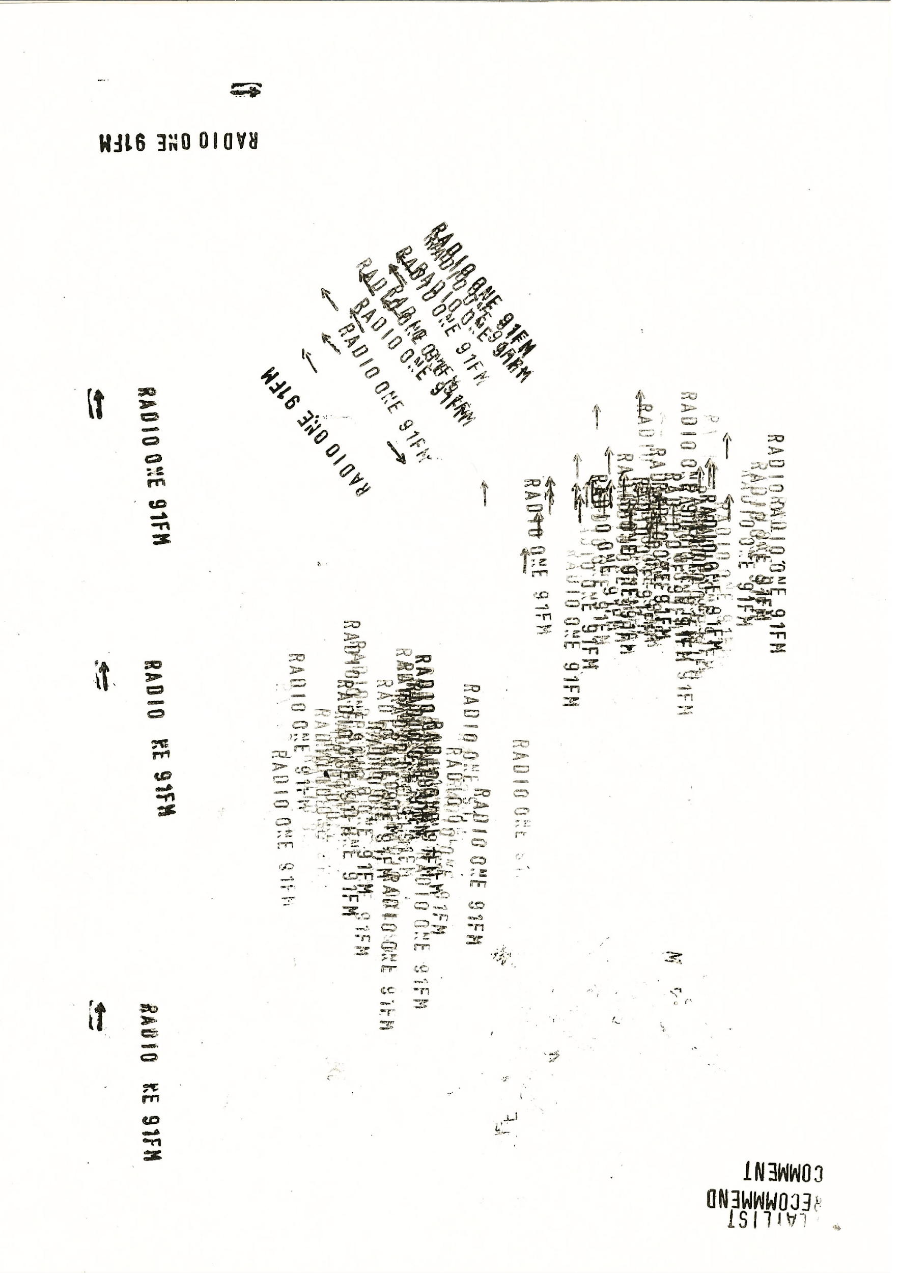
Volunteer Application Form 2026
There’s loads of ways to get involved at your favourite radio Station! Hosting shows, helping at events, voicing adverts, writing about or photographing gigs and more 😊
Fill out the form and drop it up at the station or send it to r1@r1.co.nz. There’s also an online version @ r1.co.nz. We’d love to hear from you!

Name:
Phone #:
Preferred Pronouns:
Email:
Application date:
Age:

Are you a student? If so, what are you studying?

Why would you like to volunteer at Radio One? What are your goals being involved?

Do you have any relevant experience or skills?

Are you comfortable with a Police Background check?

What areas of Radio One are you interested in working in?
- Hosting Shows
- Voicing Ads
- Interviewing Artists
- Video Content
- Event Assisting

- Writing Reviews
- Writing News
- Photography
- Videography

If you were to play 5 songs on Radio One what would they be? (We’d love a kiwi artist or 2)
1.
2.
3.
4.
5.
Cheeky extra:


Do you have any other special interests, fav genres/scenes or info you’d like to share with us?

